**TITLE OF LAB: (DIODES IN SERIES AND PARALLEL)**

**Lab No. #03**



**Spring 2022**

**CSE-206L Electronic Circuits Lab**

Submitted by

**Safi Ullah Khan : 20PWCSE1943**

Class Section: **B**

“On my honor, as student of University of Engineering and Technology, I have neither given nor received unauthorized assistance on this academic work.”

Student Signature: ______________

Submitted to:

**Engr. Abdullah Hamid**

(Monday, June 19th, 2022)

**Department of Computer Systems Engineering**

**University of Engineering and Technology, Peshawar**

**Objective:**

* To know about the combination of diodes
* To know the forward and reverse threshold in series combination
* To know about current in parallel diodes.

**Equipment:**

* power supply

**Components:**

* Silicon (D1N4002)
* Potentiometer
* Resistor: 1kΩ,

**What Is diode:**

A diode is a two-[terminal](https://en.wikipedia.org/wiki/Terminal_(electronics)) [electronic component](https://en.wikipedia.org/wiki/Electronic_component) that conducts [current](https://en.wikipedia.org/wiki/Electric_current) primarily in one direction (asymmetric [conductance](https://en.wikipedia.org/wiki/Electrical_conductance)); it has low (ideally zero) [resistance](https://en.wikipedia.org/wiki/Electrical_resistance_and_conductance) in one direction, and high (ideally infinite) [resistance](https://en.wikipedia.org/wiki/Electrical_resistance_and_conductance) in the other.

**Series Configuration:**

Series connection means a side-by-side connection. When two components are connected in series, they have one common junction.

The variation of voltage and current in a series connection is as follows:

* Potential difference across every component is different.
* The current across every component connected in series remains the same.

**Diode of Characteristics in Series Configuration:**

When connected in series, we observe the following properties to hold true among the diodes:

Resultant diode’s forward voltage increases.

Reverse blocking capabilities of diodes are increased in series connection

**Schematics:**

I build the following circuit.

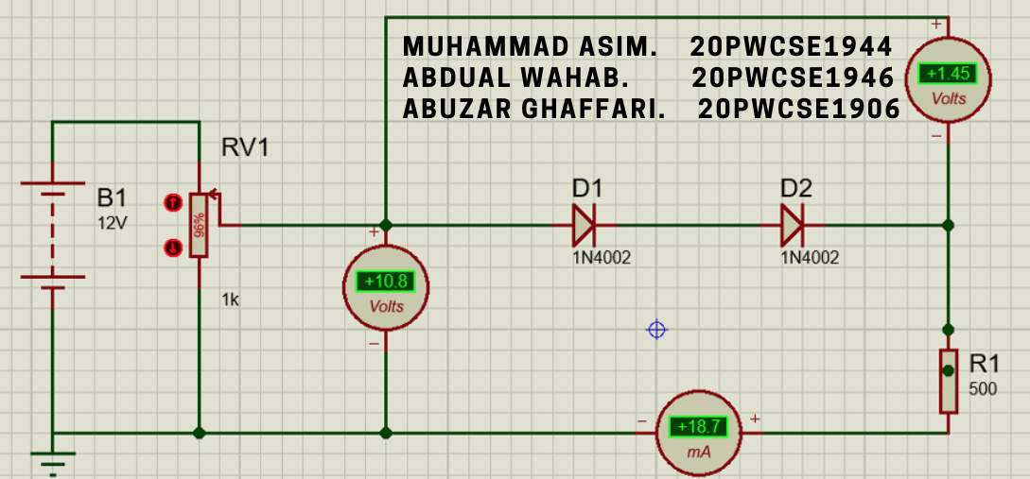

Figure 1: Circuit for 2 silicon diodes in series in forward biased.

I would occasionally switch the meters to micro and milli to get more precise readings. First let’s look at the graph of a single diode from previous lab.

Figure 2: IV graph of single silicon diode taken from previous lab

Now let’s compare the new plot.

Figure 3: IV graph for 2 silicon diodes in series

I actually wanted to confirm if this was indeed the case so I decided to use the DC sweep feature in Proteus to have Proteus plot the IV graph.

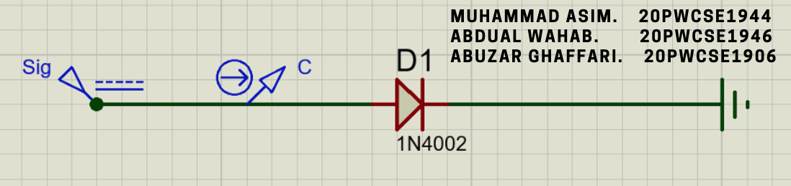

Figure 4: Schematic for DC sweep of single diode

The plot I got from Proteus is following.

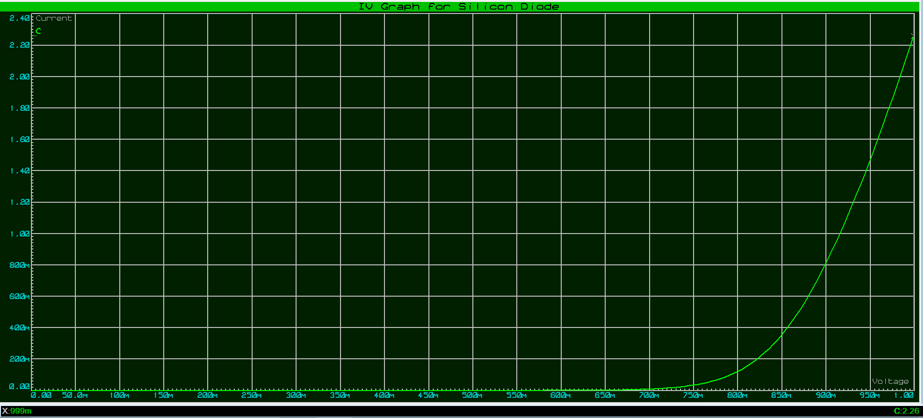

Figure 5: Forward biased IV graph for single silicon diode plotted by Proteus using DC sweep

I then designed the following schematic for DC sweeping the current through two diodes in series.

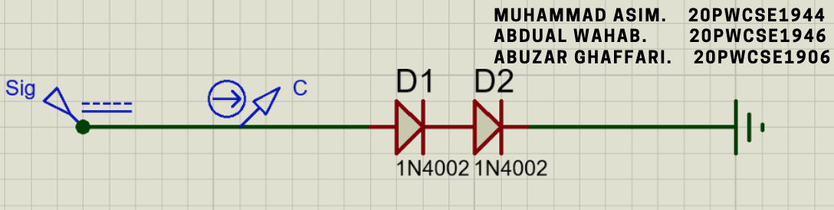

Figure 6: Schematic used for DC sweeping current through 2 diodes

And this was the graph I got.

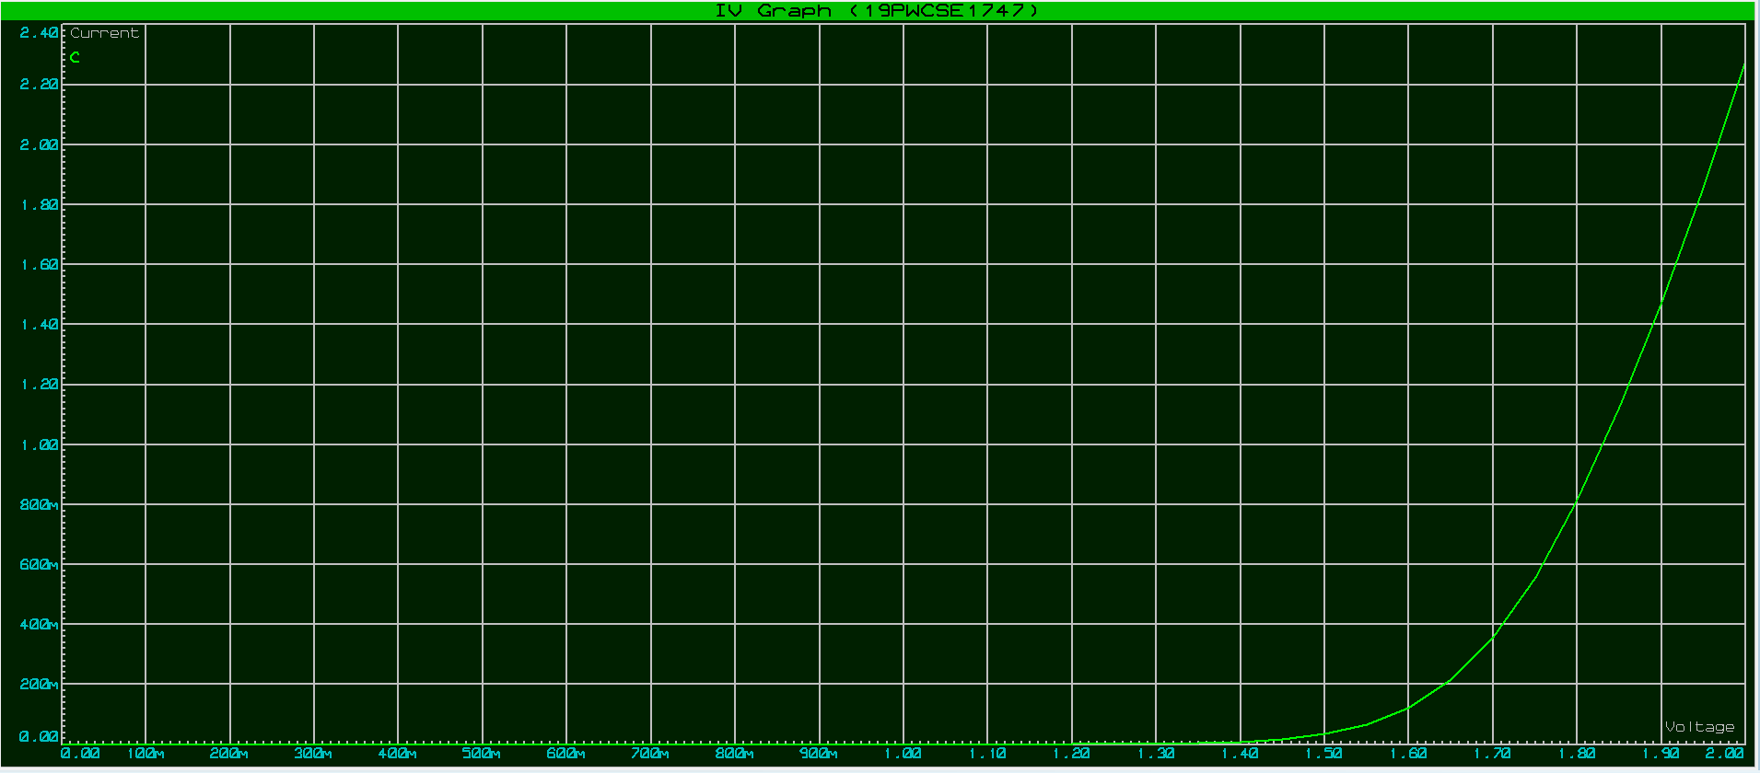

Figure 7: Graph of DC sweep current through 2 diodes in series

This somewhat verifies our values.

I then just changed the direction of both the diodes to view the reverse biased current.

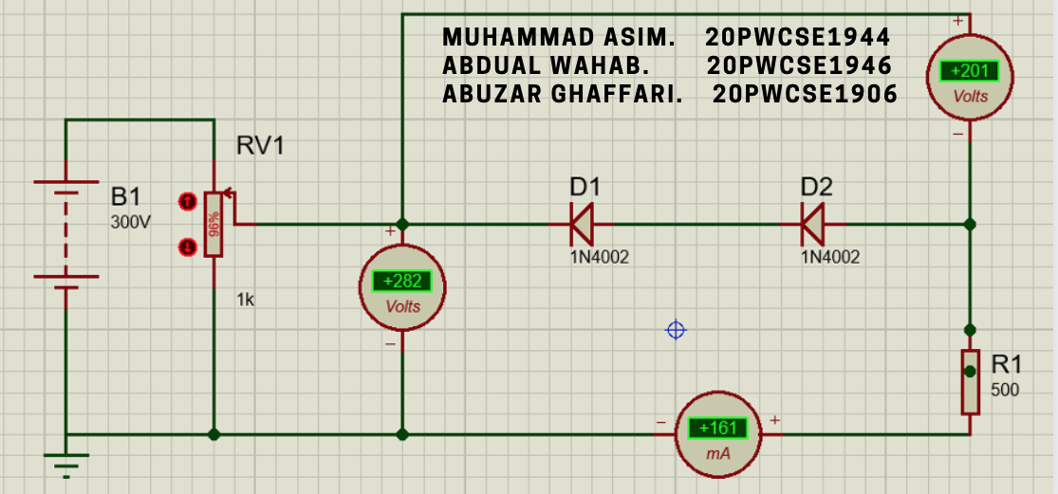

Figure 8: Reverse biased schematics.

Then I noticed readings and plotted the following.

We can compare it with the graph of single diode reverse biased. I actually rebuild the circuit for the single diode reversed biased and noticed values.

I build the following for circuit for parallel current.

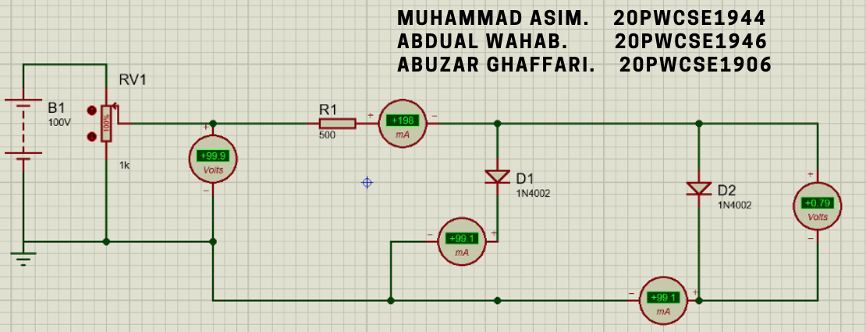

Figure 9: Circuit of parallel diode

I build it in this way because we needed to check if the total current equals sum of the currents through individual diodes. The Ammeter at the top measures the total current while the two Ammeters that are connected next to each diode measure current through that specific diode. As seen in this image, the total is equal to the sum. While the image above verifies it for one value, I build the circuit to draw graph of total current, the currents through individual diodes over an interval to verify it.

I build the following for DC sweeping.

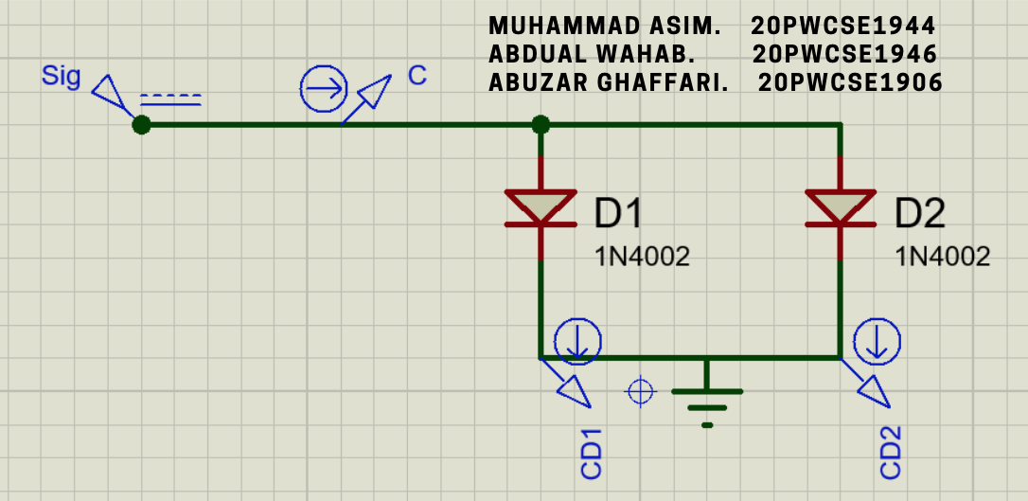

Figure 10: DC sweep schematics for parallel diodes

Here the current pointer C will measure the total current while CD1 and CD2 will measure the currents through the diodes. I ran it from 0 volts to 10 volts and got the following graph.

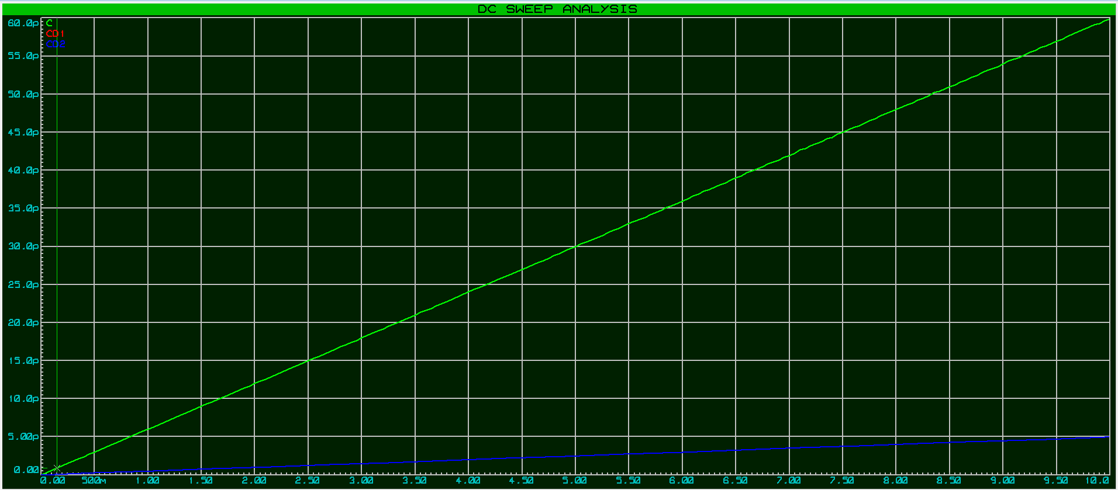

Figure 11: DC sweep graph of currents

The green indicates total current; Blue indicates current through D2 and red indicates current through D1. Red is not visible because red and blue overlap. Since blue is not clearly visible, I thought it would be better to graph it in excel. I exported the data from above graph and pasted it bellow.

You cannot view current through D1 (the red one) since the green line overlaps it. You can edit the data of the above graph to switch between viewing currents through D1 or D2. Above graph clearly verifies that the total current equals sum of currents through diodes, which was the task of lab.

**Conclusion:**

This lab helps us to understand the behavior of diode in series and parallel combination. This lab also helps to use different types of diodes and to check the effect of different diode in series and parallel combination.

**---------------------------------THE END-------------------------------**